**How do Participants Check Balance on the card?**

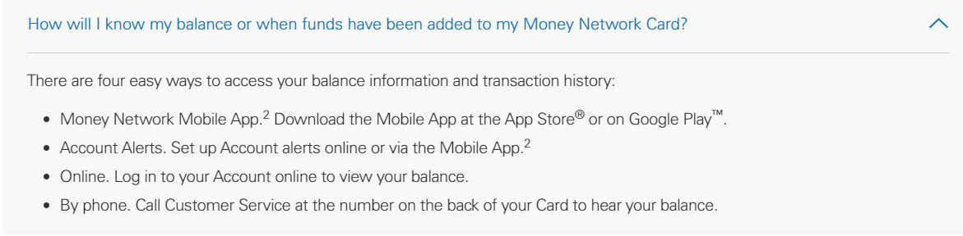

**What if Participant forgot their PIN?**

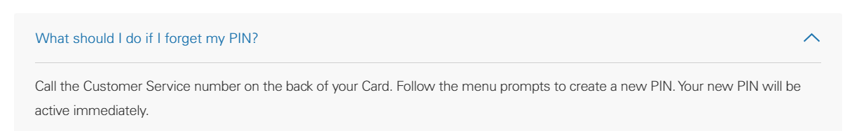

**What if Participant Card is stolen?**

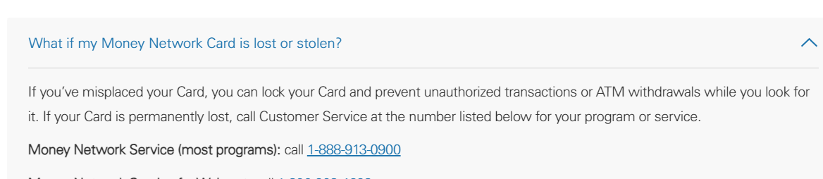

**How do I Change Visit Milestones?**

Reach out to [researchstipend@uth.tmc.edu](mailto:researchstipend@uth.tmc.edu) to change the milestones and amounts

**What do I do if Visit/Milestone not on the menu?**

Skip the “Milestone” section and only enter data into the “Optional Reimbursement” section. (see screenshot below)

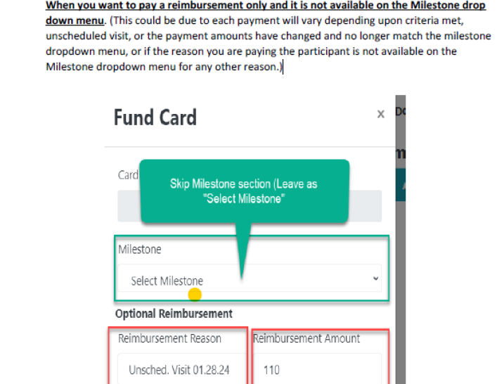

**What if Participant Lost Card:** See guidance document “Lost Card” Do not give them a new card they will need to call to have a replacement card mailed however see details on guidance document.

**Should I use Reloadable cards, One time cards or Both?**

As a general rule, If participant payments are less than $600 in a year, One time (OT) cards are used. If participant payments are $600 or greater for calendar year, Reloadable cards are used.

1. **If payments are less than $600 you should always use OT** even if multiple visits.

WHY?

* Reloadable cards require social security ID to set up reloadable account due to banking regulations
* Reloadable cards require W-9 form to be signed and uploaded in Redcap
  + participants do not meet the criteria to be required to complete a W-9 form
  + participants are not going to be happy about having to provide SS ID/W-9 if their payments are low
* Reloadable cards submissions go through an identification verification with the bank
  + if the name/DOB/Address/SSID do not pass banking verification the card will be placed on hold
* If multiyear study: in addition, if the study lasts for more than 2 years the card will need to be replaced after 2 years.
  + All SPA Card gift cards expire within 2 years

1. SPA recommends to set up **both RL and OT** account for a single study when:

* Payments are =>$600 but some participants may not have SSN or may not have stable address
  + Reloadable cards submissions go through an identification verification with the bank
    - if the name/DOB/Address/SSID do not pass banking verification the card will be placed on hold
  + Setting up both accounts at start of study will allow you easily use the OT cards if a participant does not have SSN or does not have a stable address to avoid delay in your team having to set up new application.

**How do I set up a Second SPA Card Account?**

If you are using Reloadable SPA cards, and find a participant does not have a SSN, or a valid address, you will need to set up a separate account for One Time use cards.

1. Submit a new SPA Card application that mirrors the Reloadable Card application.
   1. EXCEPT
      1. Add “OT” in front of the study title
      2. Select card type: “One time “

By adding OT in front of the title, you will easily know which one to select from the “list of Projects” page.